Data Structure and Algorithm

Laboratory Activity No. 3

Translating Algorithm to Program

|  |  |
| --- | --- |
| *Submitted by:* | *Instructor:* |
| Elpedes, Glen Jorge A. | Engr. Maria Rizette H. Sayo |

AGUST, 02, 2025

# Objectives

Introduction

Data structure is a systematic way of organizing and accessing data, and an algorithm is a step-by-step procedure for performing some tasks in a finite amount of time. These concepts are central to computing, but to be able to classify some data structures and algorithms as “good,” we must have precise ways of analyzing them.

This laboratory activity aims to implement the principles and techniques in:

* Writing a well-structured procedure in programming
* Writing algorithm that best suits to solve computing problems
* Writing an efficient Python program from translated algorithms

# Methods

• Design an algorithm and the corresponding flowchart (Note: You may use LucidChart or any application) for adding the test scores as given below if the number is even: 26,49,98,87,62,75

• Translate the algorithm to a Python program (using Google Colab)

• Save your source codes to GitHub

# Results

Algorithm

**Step 1:** **Start**

**Step 2:** Initialize a variable sum = 0

**Step 3:** Create the list of test scores: scores = [26, 49, 98, 87, 62, 75]

**Step 4:** If the score is % 2 == 0 add it to sum

**Step 6:** Print the final sum

**Step 7:** **End**

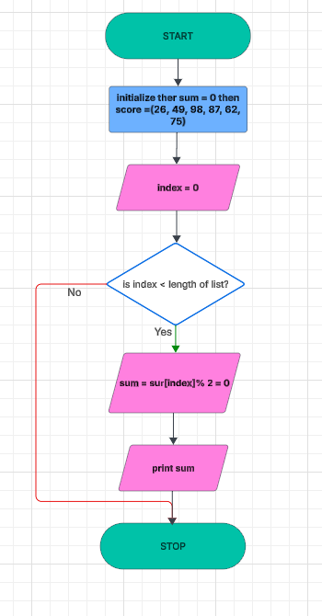

Figure 1. Flow Chart

The flowchart just indicates how to iterate over a list of test scores and sum only the even ones. It begins by initializing the total to zero, then tests each score individually. If a score is even, it is added to the total. This is repeated until all the scores have been tested. Finally, the program displays the resultant total and terminates. It's akin to wading through a collection of numbers and selecting only the even ones to sum.

Figure 2. Source Code

This program is a basic program that goes through a list of test scores and sums only the even numbers. It goes through each number individually using a while loop. If a number is even, it adds it to a running sum. After all the scores have been scanned, the program prints the sum and returns it. For instance, using the list [26, 49, 98, 87, 62, 75], it identifies the even numbers (26, 98, and 62), sums them up, and presents the result: 186.

# Conclusion

We created an algorithm and flowchart to add only the even test scores from a given list. Then, we translated that logic into Python code using different methods. The process helped break down the problem clearly and led to the correct result: a sum of **186**. This activity showed how planning with algorithms and flowcharts makes coding easier and more accurate.

**References**

[1] “Python. How to sum up all even integers in a list?,” *Stack Overflow*. <https://stackoverflow.com/questions/30314910/python-how-to-sum-up-all-even-integers-in-a-list>

[2] Vishal, “Python Programs for Summing Even Numbers from 1 to n,” *PYnative*, Mar. 31, 2025. <https://pynative.com/python-sum-even-numbers-from-1-to-n>